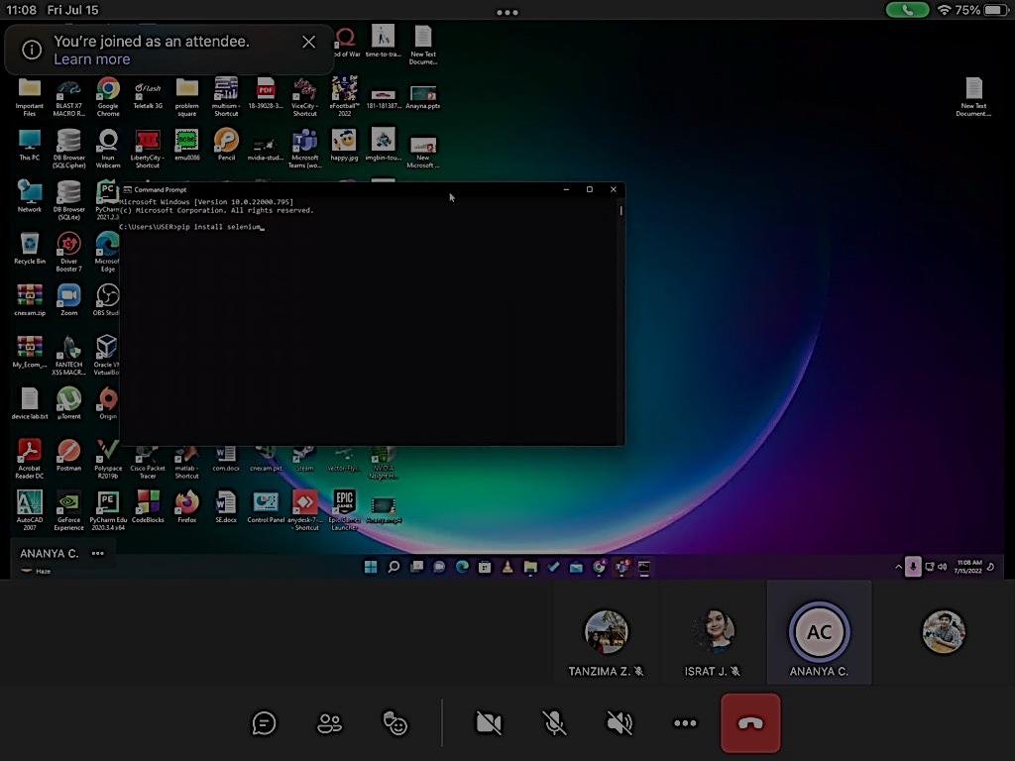

Before installing Selenium, we have to install Python first. As we have installed Python in our pc so we just skip that. Now for installing selenium we open Command Prompt and use this command - “pip install selenium”.

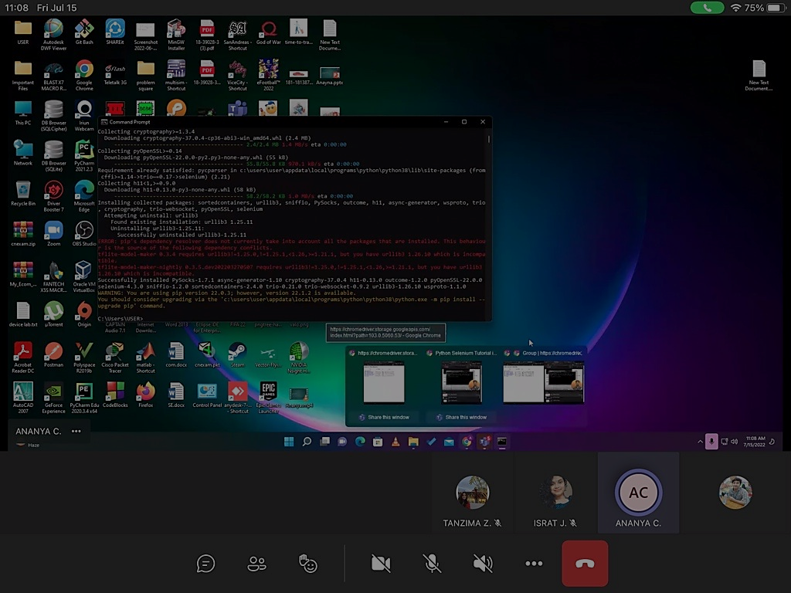

After successfully installed selenium there would be appear a message like “Requirement already satisfied”

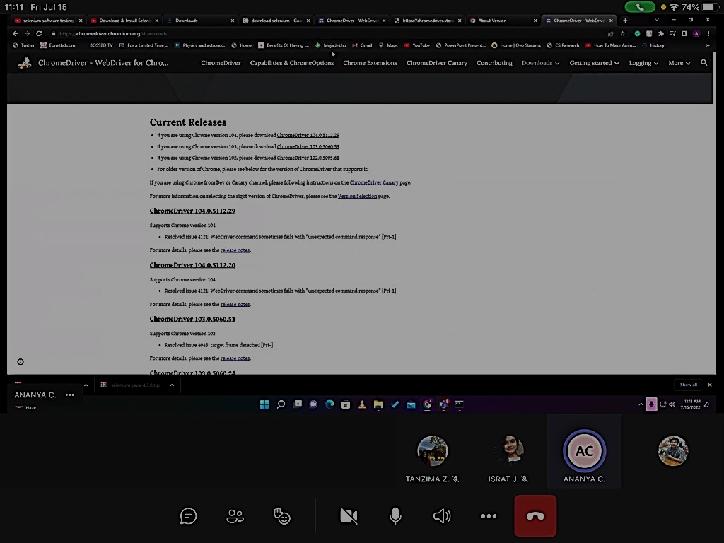

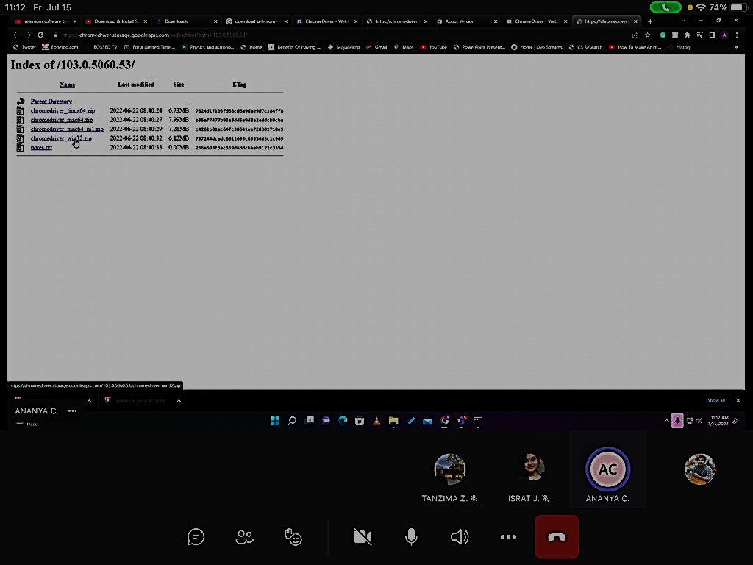

Now we have to download Google Chrome driver as per our Google Chrome version. Here we have download Chromedriver_win32. After that we paste the Chromedriver to selenium folder.

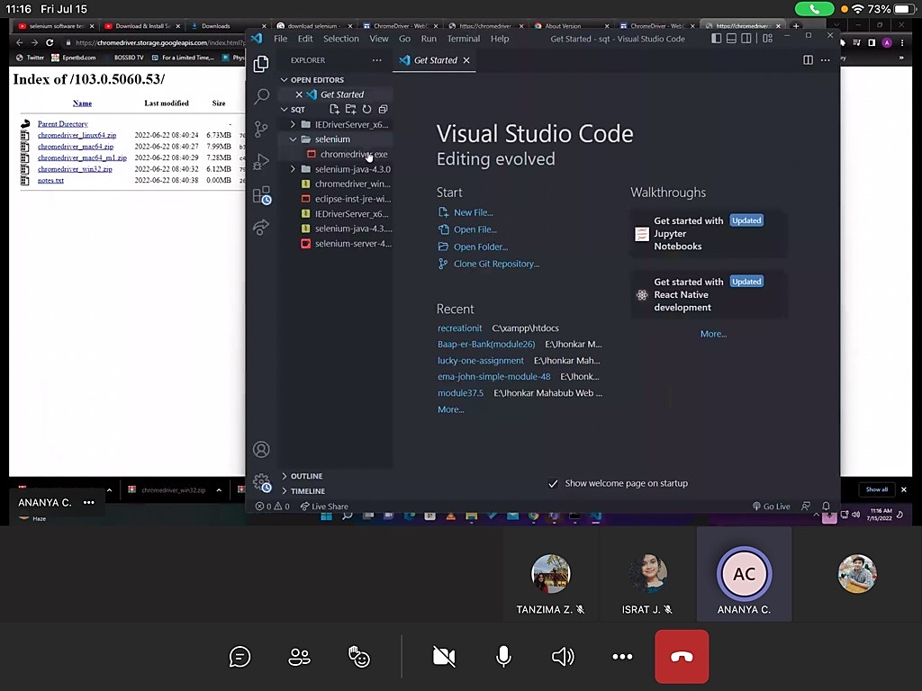

Now we open Selenium folder by Visual Studio Code.

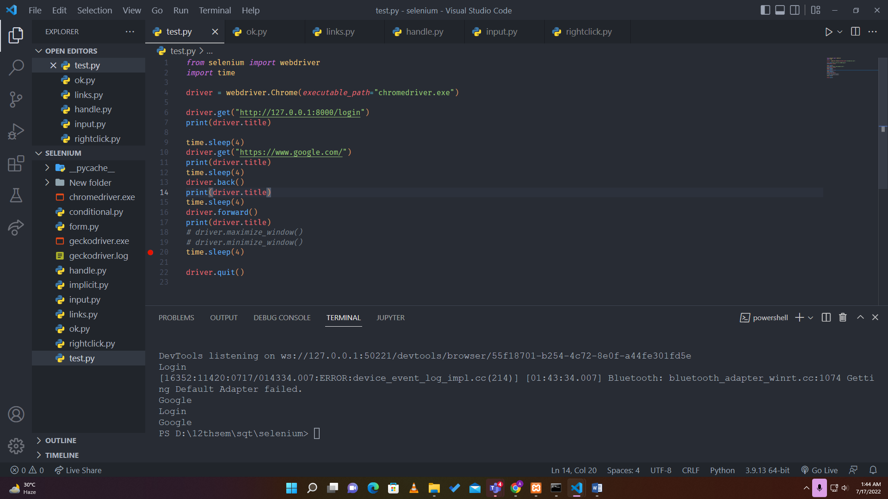

Here in this test.py we have checked the navigational conditions and at first we have opened the login page and printed the title of the login page as “Login”.

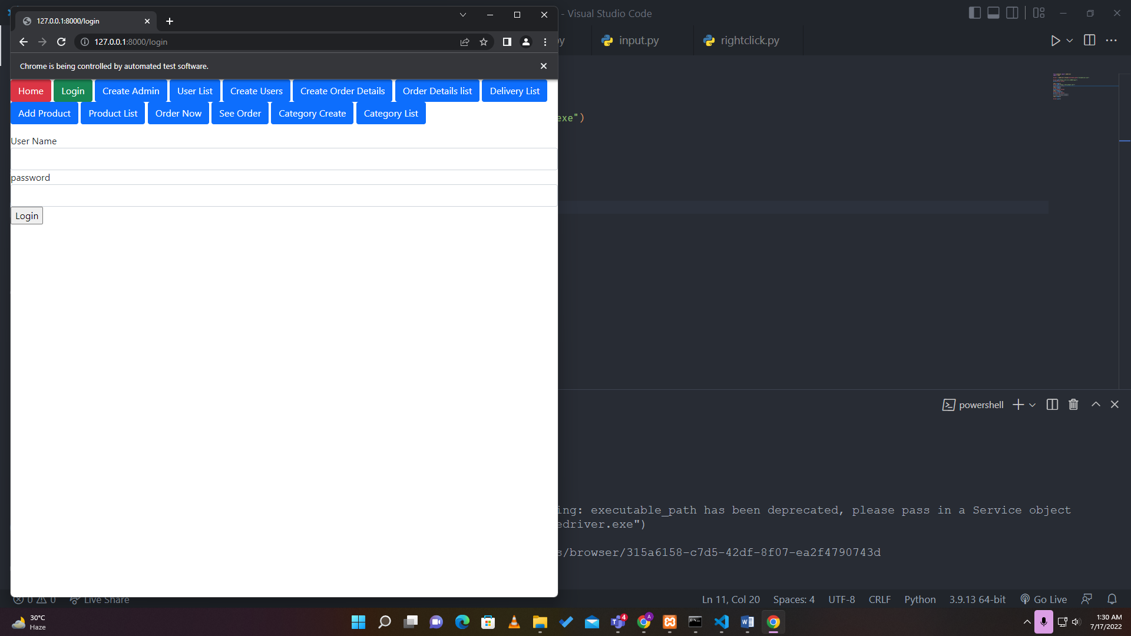

A file created as “test.py” under selenium to ensure if the testing process is working properly or not. Here the file automatically opened the login page path and then it goes to the google page path after 4sec delay.

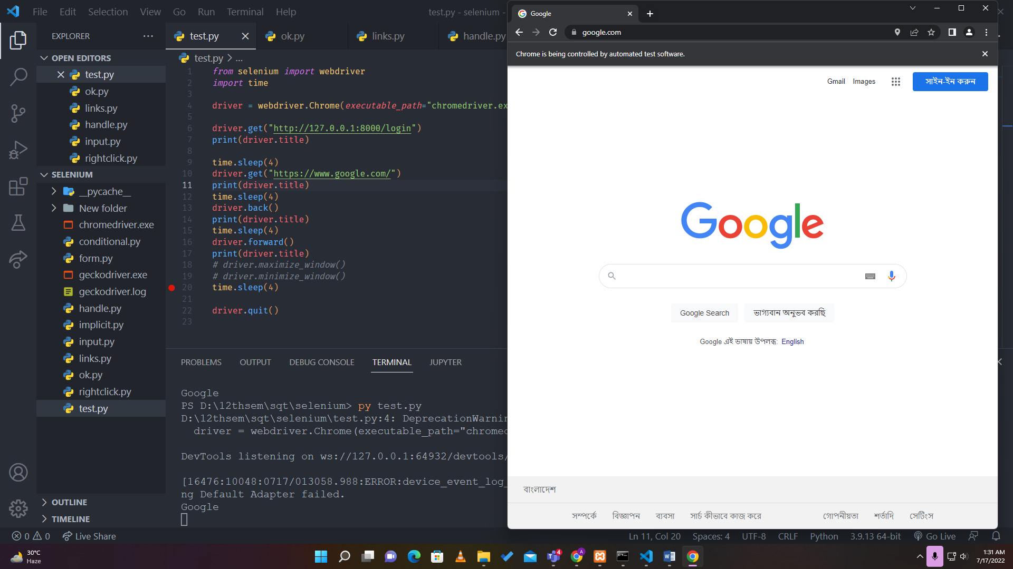

After opening the google page and print the title then it waits for another 4 secs and goes backward to the previous page which was login page and again prints the title of the page.

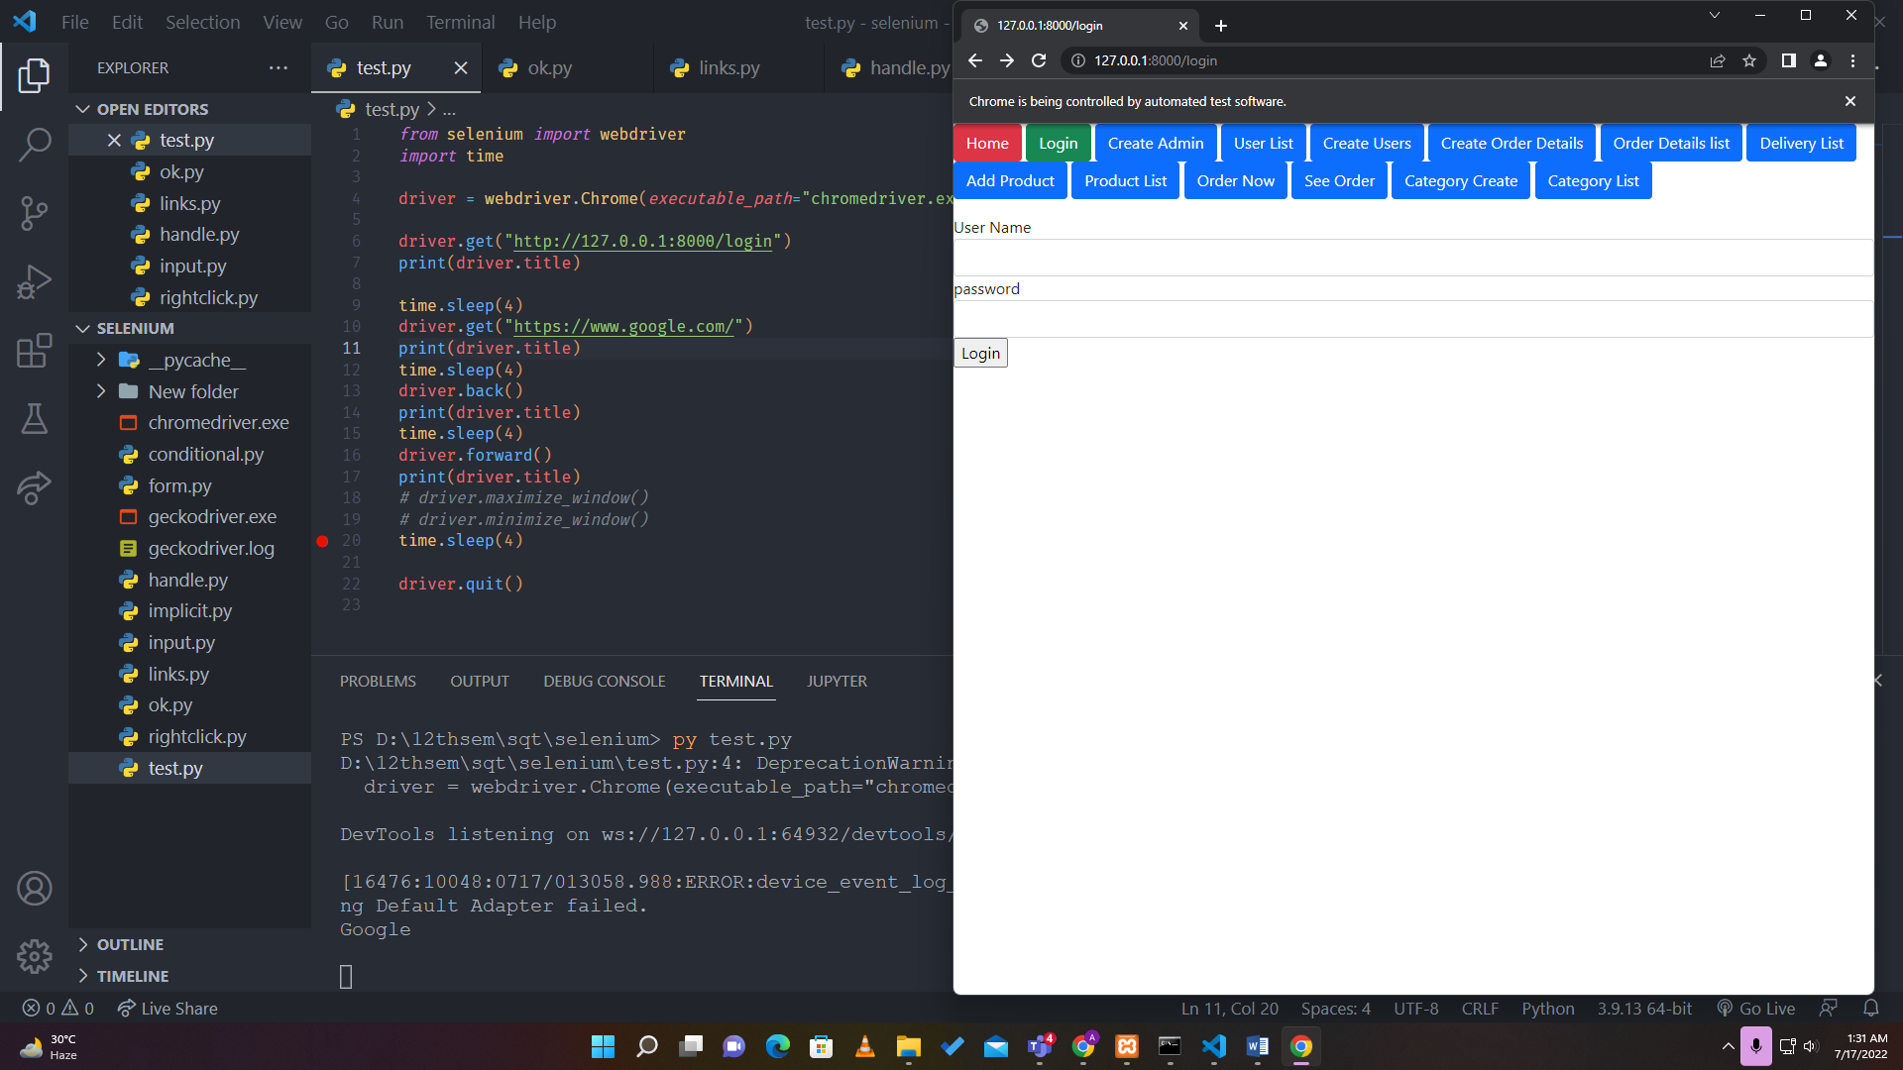

Here after that it again awaits 4 sec and goes to forward page which was the google page and prints the title of the Google again.So after that the test driver quits the test.

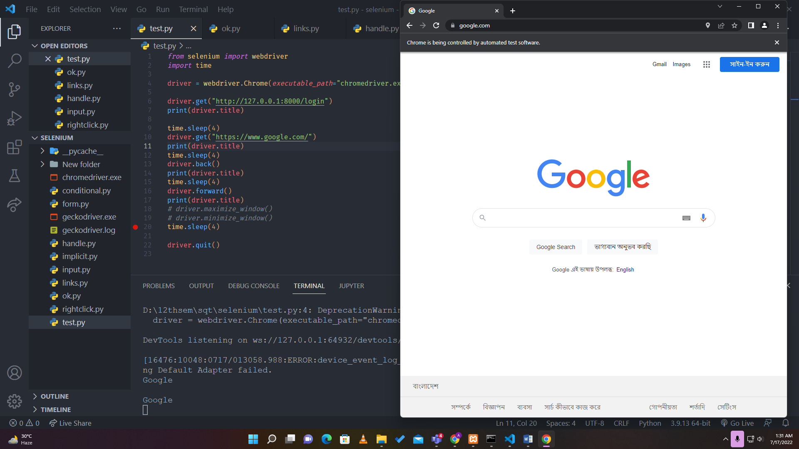

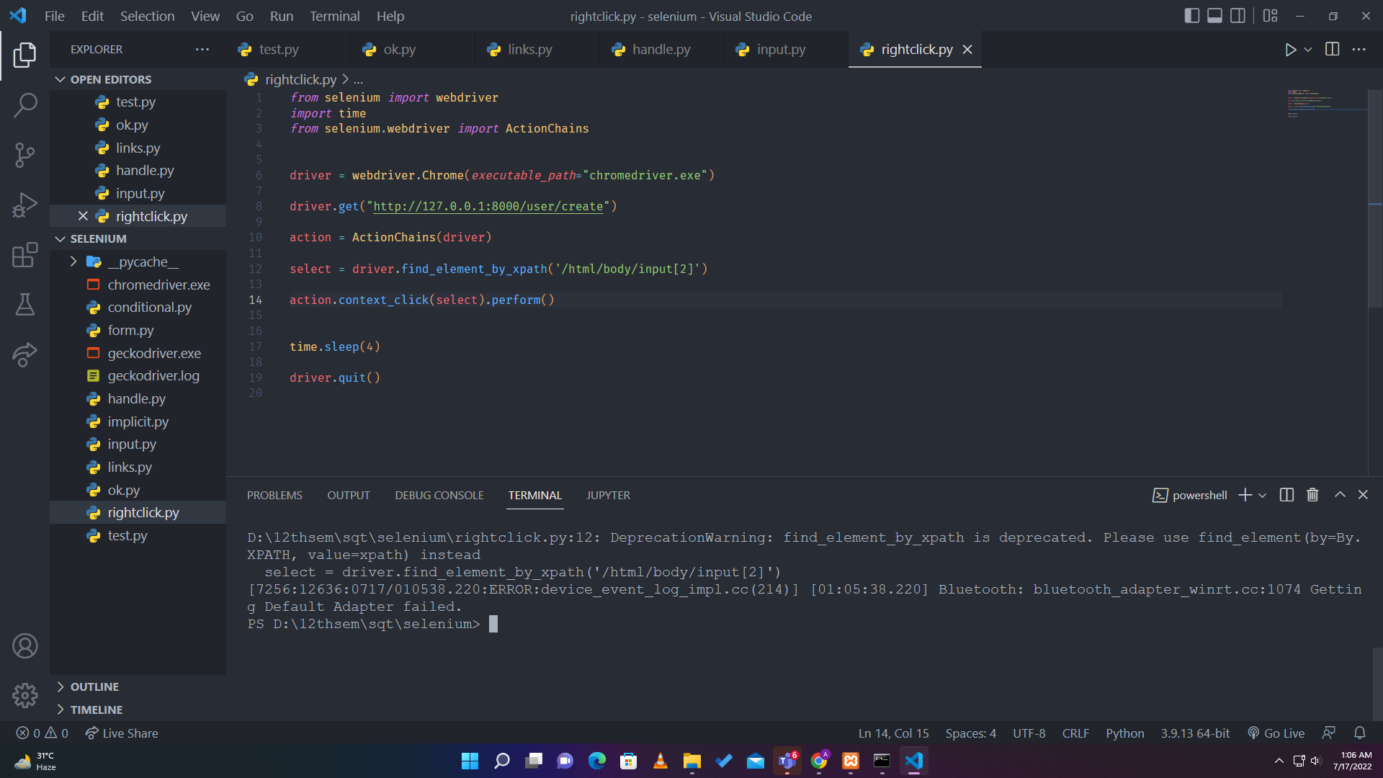  
Here in this file when we executed the rightclick.py file it opened the Create user path of out project and there is a input field of Username. We declared the variable called select and by using the action variable we have perfomed the right click button and it perfomed as the image given bellow. 